Get connected and don’t miss out !

To receive news and information about Orange Glen High School Music Department register for the **‘TellMeAboutOGMusic’** Campaign..

**Three ways to register:**

(1)

Register your email address at [oghsmusic.weebly.com](http://www.oghsmusic.weebly.com)

(2)

Send an email to [oghsmusicfc@gmail.com](mailto:oghsmusicfc@gmail.com) with “TellMeAboutOGMusic” at the subject line

(3)

Send us a mail with your return address at

“TellMeAboutOGMusic”

c/o Ted Meyer, Music Director

2200 Glenridge Rd,

Escondido, CA 92027

Include the name of the music student you’re supporting.

Visit us online at

[oghsmusic.weebly.com](http://www.oghsmusic.weebly.com)

**Coming Soon, details TBD:**

Annual Gala and Auction @ Room 700

Holiday Bazaar @ Parking Lot

Winter Concert @ CCAE

Online Fundraising @ gofundme.com

**For comments or suggestions, please email us at: oghsmusic@gmail.com**

**August 22 – 23 (Saturday & Sunday) 10am – 4pm**

FREE Electronics Recycling (Donations appreciated)

Paper Shredding $5 per file box

Shredding Collected from 10-4

Docs shred on site beginning 3:30 on Saturday & Sunday

Food & Fun: **Panda Express** – Aug 28, Friday – 11am to 8pm

1485 E. Valley Parkway - Flyer needed

**Rubio’s** – Sept 24, Thursday – 4pm to 8pm

1485 East Valley Parkway – Flyer needed

**Chipotle** –Info to be announced

Flyers also available at [oghsmusic.weebly.com](http://www.oghsmusic.weebly.com)

No Out-of-Pocket Fundraising

Ralphs Community Programs

Sign-up on or after Sept 1, 2015

Go to [www.ralphs.com](http://www.ralphs.com) to register your Ralphs Card

for ‘Orange Glen Band Association’ NPO #93473

**Ralphs will donate a percentage of eligible purchases:**

Up to $200 per month of eligible purchases 1%

$200.01 and $350 per month of eligible purchases 2% of amount over $200

$350.01 and $500 per month of eligible purchases 3% of amount over $350

Over $500 per month of eligible purchases 4% of amount over $500

Renewal of OGBA registration is required annually every Sept 1st.

**Electronics Recycling and On-Site Paper Shredding**

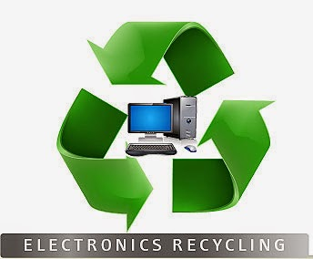

Fundraising

Opportunities

**Donations and proceeds are for the benefit of the:**

Orange Glen High School Music Department

